SQL QUIERIES TEST 1

Create a Supplier table as shown below : (for questions from 1 to 10)

Sup_No  (Primary Key) | Sup_Name | Item_Supplied | Item_Price | City
S1 | Suresh | Keyboard | 400 | Hyderabad
S2 | Kiran | Processor | 8000 | Delhi
S3 | Mohan | Mouse | 350 | Delhi
S4 | Ramesh | Processor | 9000 | Bangalore
S5 | Manish | Printer | 6000 | Mumbai
S6 | Srikanth | Processor | 8500 | Chennai

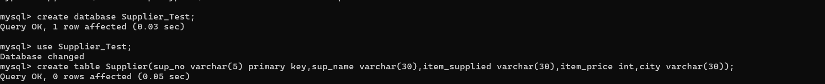

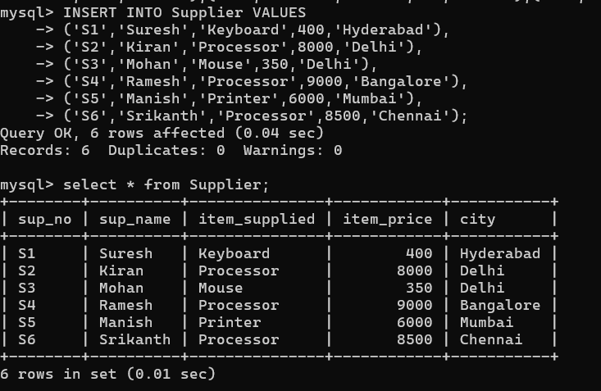
  - Write sql query to display Suplier numbers and Supplier names whose name starts with ‘R’

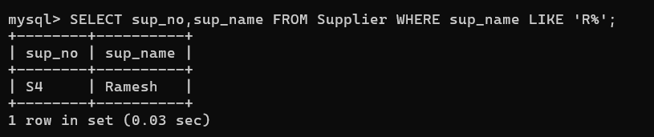

  - Write sql query to display the name of suppliers who supply Processors and whose city is Delhi.

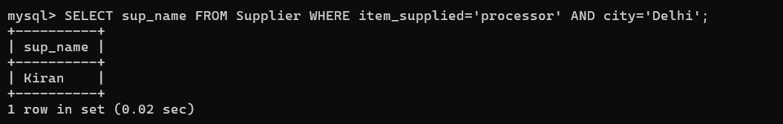

  - Write sql query to display the names of suppliers who supply the same items as supplied by Ramesh.

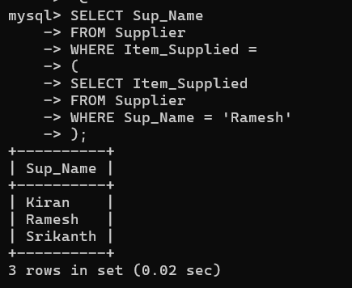

  - Write sql query to increase the price of Keyboard by 200.

  - Write sql query to display supplier numbers, Suplier names and itemprice for suppliers in delhi in the ascending order of itemprice.

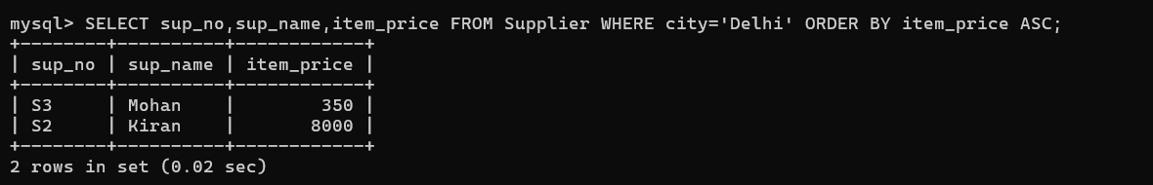

  - Write sql query to add a new column called CONTACTNO.

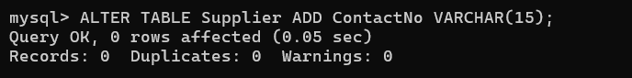

  - Write sql query to delete the record whose itemprice is the lowest of all the items supplied .

  - Create a view on the table which displays only supplier numbers and supplier names.

  - Write sql query to display the records in the descending order of itemprice for each itemsupplied.

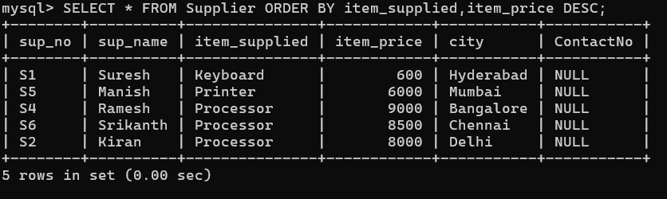

  - Write sql query to display the records of suppliers who supply items other than Processor or Keyboard.
